# E-Receipt System

1. Login

Website：<http://app/CCLF/>

Testing: <http://192.168.18.240/CCLF/>

Management Code：IT Helpdesk

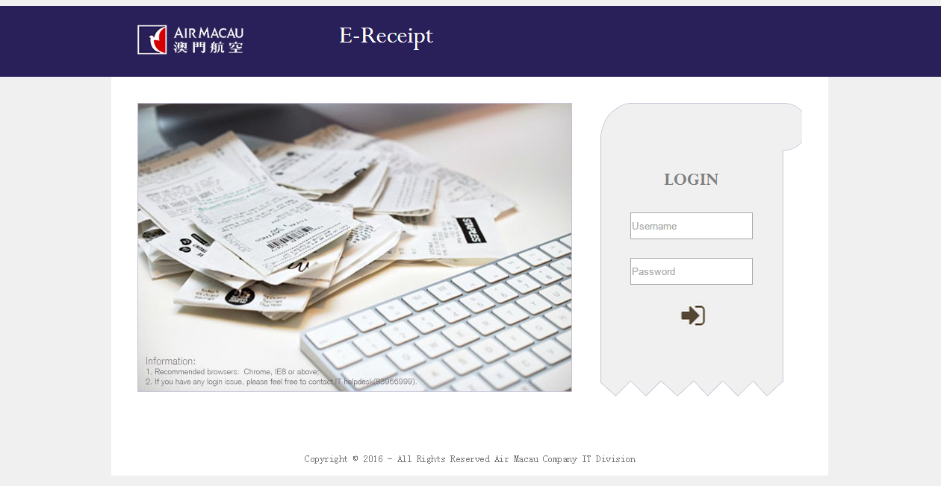

1. Cabin Crew Load Factor Query

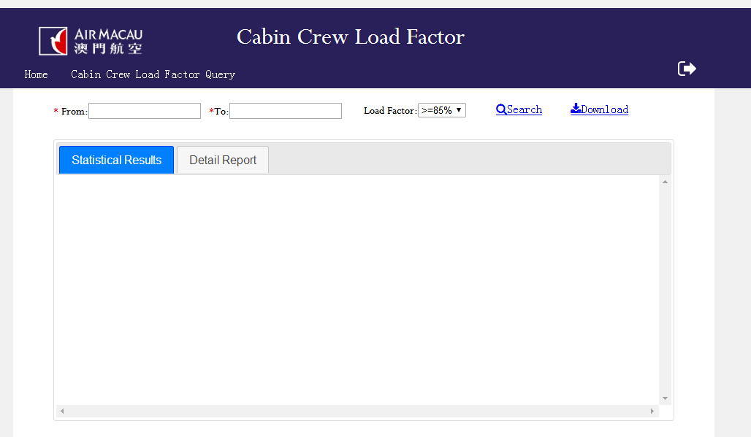

* 1. Search

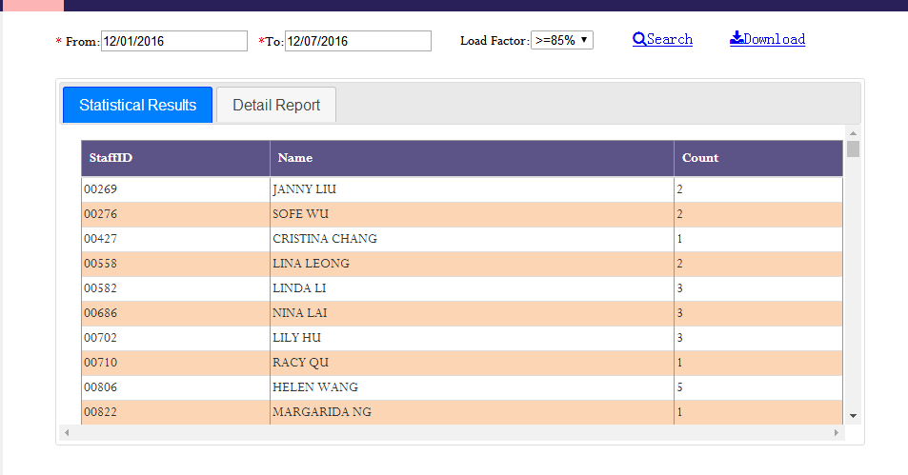

* 1. Download

